**JobsBridge.com – Job Seeker**



**Objective**

Building JobsBridge as an integrated social recruiting platform for Job Seekers. Jobseekers will be connected to the talent pool through their social profiles. Building an easy signup/Sign in and Jobs Application system

Table of Contents

1 Concept Introduction 3

1.1 Project Overview 3

1.1.1 Key Benefits 3

1.1.2 Mobile Responsive Design 4

1.1.3 Site Flow 5

1.1.4 Pages/Screens 5

2 Product Functional 6

2.1 Landing Page 6

2.1.1 Jobseeker Features 7

2.1.2 Job Seeker Registration 7

2.1.3 Job Search & Apply 9

2.1.4 Job Description Page 10

2.1.5 Application Confirmation Page 10

2.1.6 Job Seeker Login and Apply 11

2.1.7 Job Seeker Dashboard 11

2.1.8 Job Seeker Profile Page 12

2.1.9 Job Seeker Insights 13

# Concept Introduction

## Project Overview

The Job seeker on the jobs bridge will have an quick sign up/Registration process enabled with social logins.

### Key Benefits

**Job Seeker**

**Seeker Social Integration**

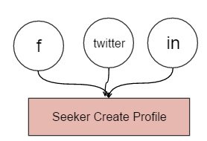 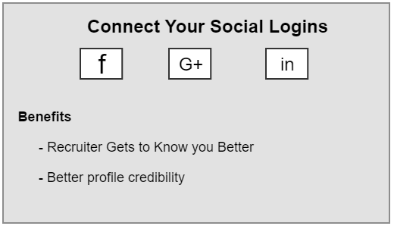

### Mobile Responsive Design

The new site will be totally responsive. Being totally focusing on **social recruiting**, mobile traffic place plays a very important role. We will initially make a responsive site. Eventually mobile app will be make for mobile users.

Currently, more than 58% of American adults own a smartphone and almost 60% of all website traffic is from mobile devices.

**Social media increases mobile visitors**

Over 55% of social media consumption now happens on mobile devices, so sharing links from social media sites like, Facebook, YouTube, Twitter, or Google Plus to your website will mean even more traffic and viewing of your website from mobile devices.

Ref: <http://www.marketpath.com/digital-marketing-insights/8-reasons-to-have-a-responsive-web-design-infographic>



### Site Flow

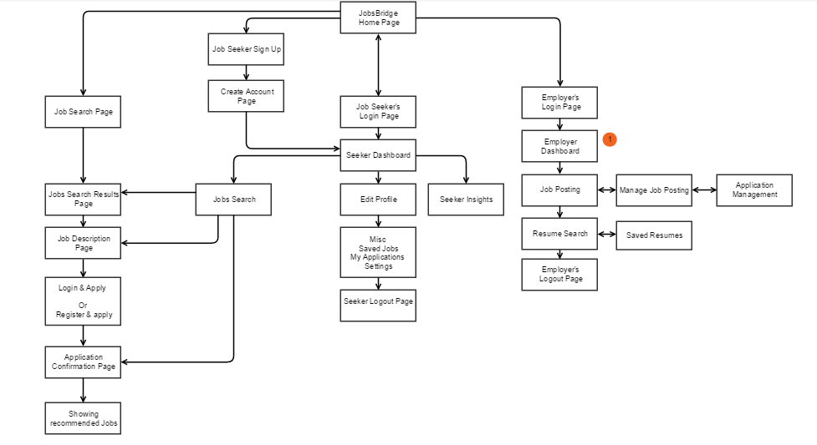

### Pages/Screens



# Product Functional

## Landing Page

The site landing page will be Job Seeker oriented and equipped elements like Job Search panel, login/Sign up, Top Jobs, benefits, top skills , top Employers. Employers

**Page Elements:**

* Job Seeker Login
* Sign up
* Jobs Seeker Benefits
* Employer Benefits
* Site Features – USP’s
* Top Employers

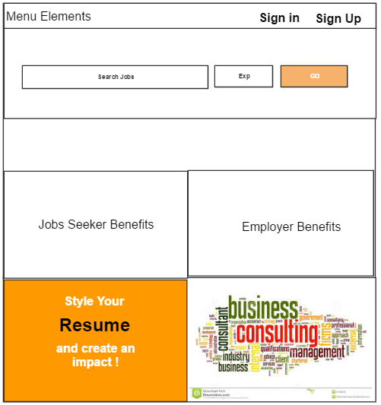

### Jobseeker Features

**Jobs Seeker Flow**

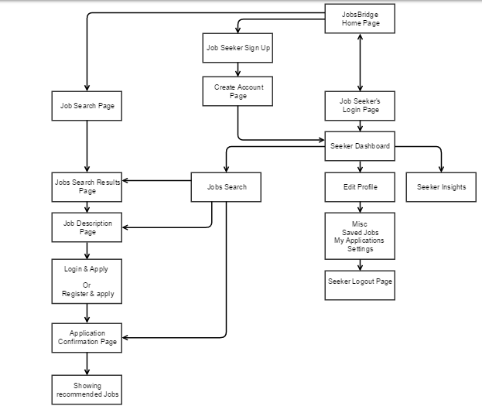

### Job Seeker Registration

Login through social plugins. This will directly take you to seeker dashboard where he can search and apply jobs.

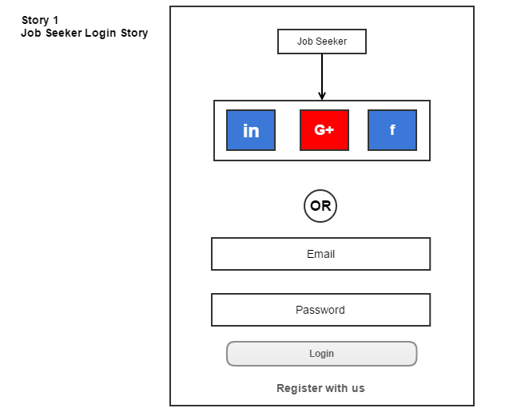

The short registration through social logins or a small registration form. Incase seeker chooses social login second screen to get his password will be asked. Or we can take this user to dashboard and an automated password mail can be sent to his email address.

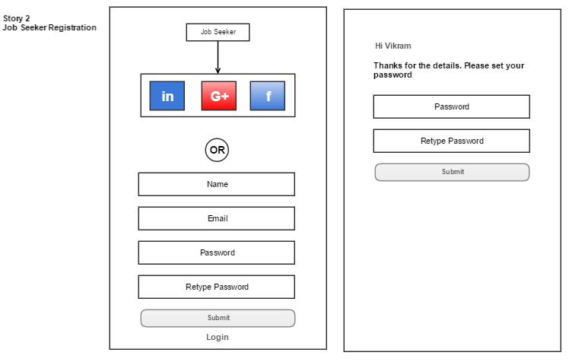

The logged in seeker once searches a job will be redirected to Jobs search page. Job Seeker will be able to apply to the Jobs available on Jobs bridge portal.

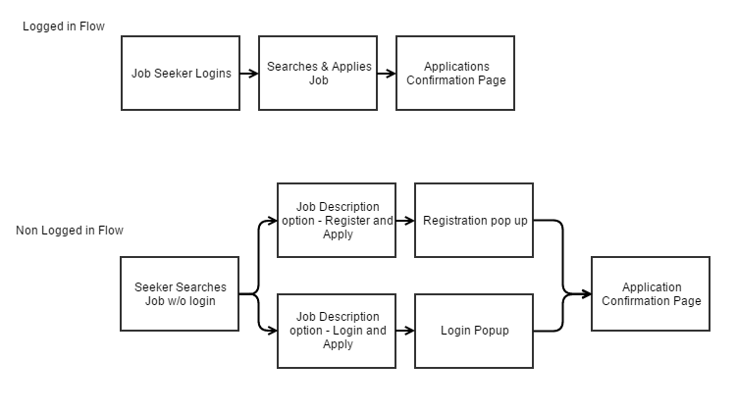

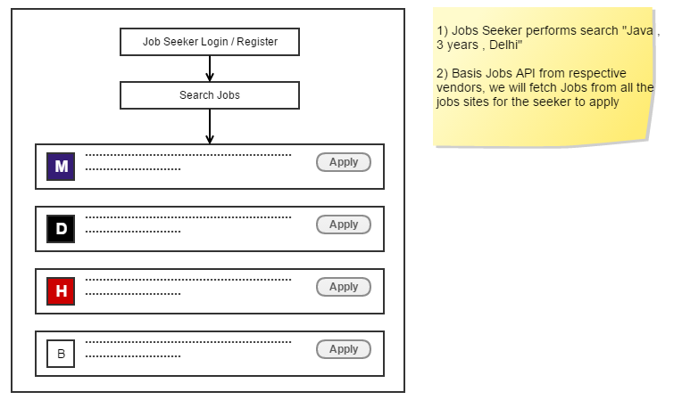



Note: Connecting seekers social logins we shall also be able to fetch users network details.

### Job Search & Apply

* + The Search bar available on the home page will allow the user to search Job.



* + Clicking on the Search Button the user will Land on to search Results page

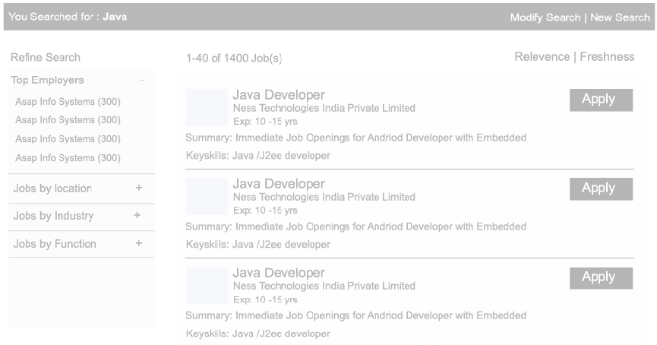

### Job Description Page

#### Generic job description page will implemented.

### Application Confirmation Page

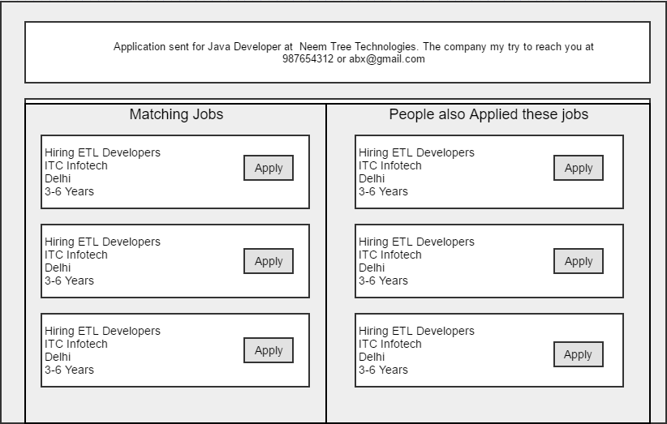

### Job Seeker Login and Apply



### Job Seeker Dashboard

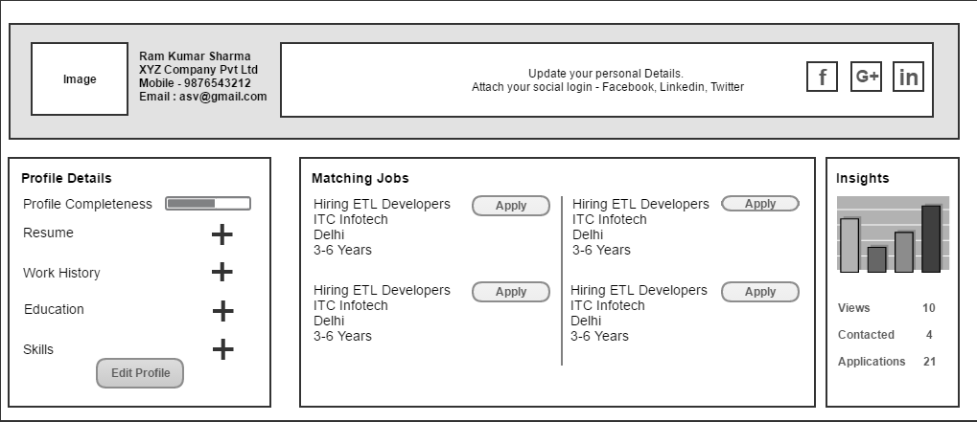

### Job Seeker Profile Page

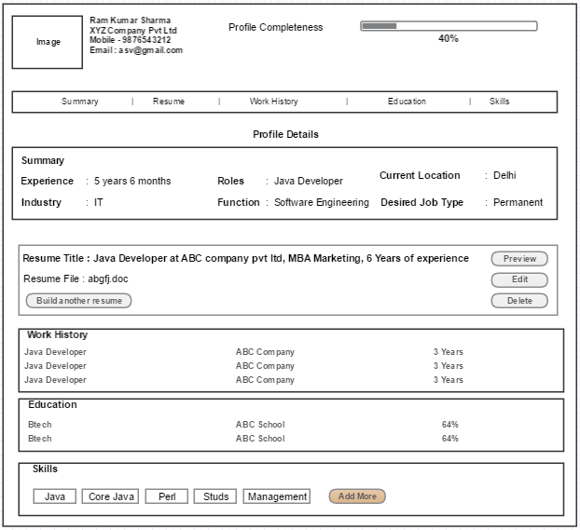

### Job Seeker Insights

